**Machine Learning**

**Assignment 1**

**(Linear Regression + Logistic Regression)**

**Chun Kit, Tsoi**

**140300468**

**Part 1**

Task 1: hypothesis = X(i,:)*theta';

Replace by hypothesis = calculate_hypothesis(X,theta,i);

Left is linear regression plot. Right is cost

When Alpha=0.01,

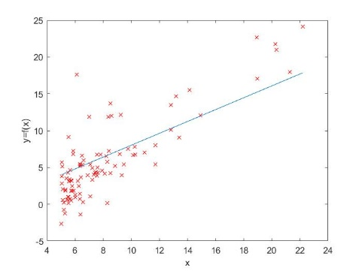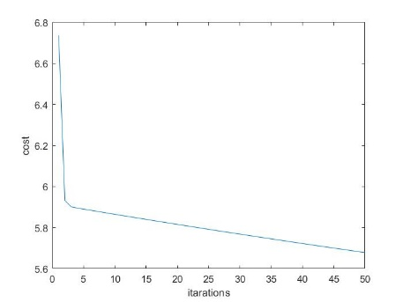

When Alpha=10,

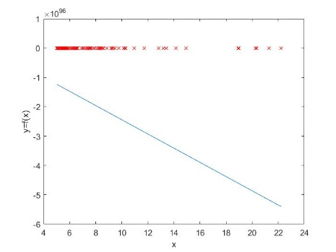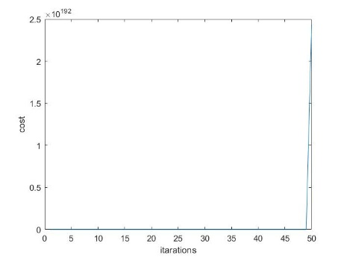

When Alpha=100,

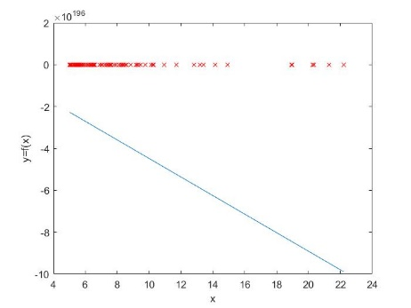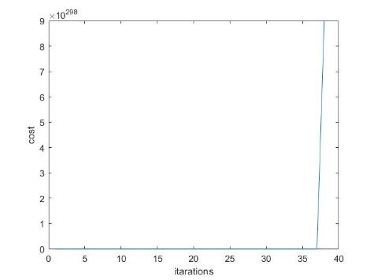

When Alpha is 0.01, the linear regression line fit well, and the cost function converge to 0 after about cost=5.7. Meanwhile, When Alpha is large, the linear regression line does not fit the data, the cost function will converge to infinity, after a long time zero-cost iteration.

Task 2: hypothesis = X(i,:)*theta'; %Add to Calculate_hypothesis

%ADD to gradient_descent

theta_2 = theta(3);

%update theta(3) and store in temporary variable theta_2

sigma = 0.0;

for i = 1:m

hypothesis = calculate_hypothesis(X, theta, i);

output = y(i);

sigma = sigma + (hypothesis - output) * X(i, 3);

end

theta_2 = theta_2 - ((alpha * 1.0) / m) * sigma;

%update theta

theta = [theta_0, theta_1,theta_2];

Alpha=0.01,0.1,1,10,100(from left to right)

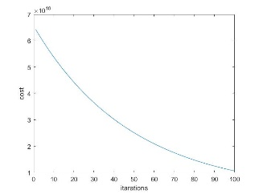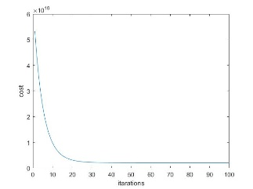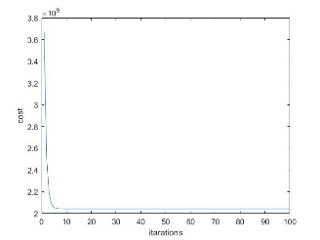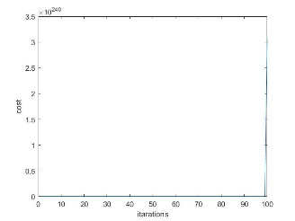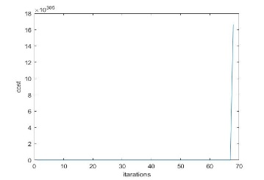

Alpha=0.01 t =1.0e+05 * 2.1581 0.6138 0.2027

Alpha=0.1 t =1.0e+05 * 3.4040 1.0991 -0.0593

Alpha=1 t = 1.0e+05 * 3.4041 1.1063 -0.0665

Alpha=10 t = 1.0e+120 * -0.0000 -1.4175 -1.4175

Alpha=100 t =1.0e+222 * -0.0000 -6.4281 -6.4281

When Alpha=0.01, the cost tends to be zero. It seems to be the best learning rate.

Add result1 = t(1) + t(2)*1650 + t(3)*3 in mllab2

result1 =1.0156e+08

Add result2 = t(1) + t(2)*3000 + t(3)*4 in mllab2

result2 = 1.8445e+08

**Task 3**

function theta = gradient_descent(X, y, theta, l, alpha, iterations, do_plot)

%GRADIENT_DESCENT do Gradient Descent for a given X, y, theta, alpha

%for a specified number of iterations

%if less than 6 arguments was given, then set do_plot to be false

if nargin < 6

do_plot = false;

end

if(do_plot)

plot_hypothesis(X, y, theta);

drawnow; pause(0.1);

end

m = size(X, 1); %number of training examples

num_col_theta = size(theta,2); %number of coefficients

cost_vector = []; %will store the results of our cost function

for it = 1:iterations

%%%%%%%%%%%%%%%%%%%%%%%%%%%%%%%%%%%%%%%%%%%%%%%%%%%%%%

% gradient descent

%%%%%%%%%%%%%%%%%%%%%%%%%%%%%%%%%%%%%%%%%%%%%%%%%%%%%%

theta_temp = theta;

for t = 1:num_col_theta

sigma = 0.0;

for i = 1:m

hypothesis = calculate_hypothesis(X, theta, i);

output = y(i);

sigma = sigma + (hypothesis - output) * X(i, t);

end

%new cost function (regularized)

if t == 1

theta_temp(t) = theta_temp(t) - ((alpha * 1.0) / m) * sigma;

else

theta_temp(t) = theta_temp(t) - ((alpha * 1.0) / m) * sigma - theta_temp(t)*((alpha * l)/m);

end

end

%update theta

theta = theta_temp;

%update cost_vector

cost_vector = [cost_vector; compute_cost_regularised(X, y, theta, l)];

if do_plot

plot_hypothesis(X, y, theta);

drawnow; pause(0.1);

end

end

disp 'Gradient descent is finished.'

if do_plot

disp 'Press enter!'

pause;

end

plot_cost(cost_vector);

disp 'Press enter!';

pause;

end

Alpha=8

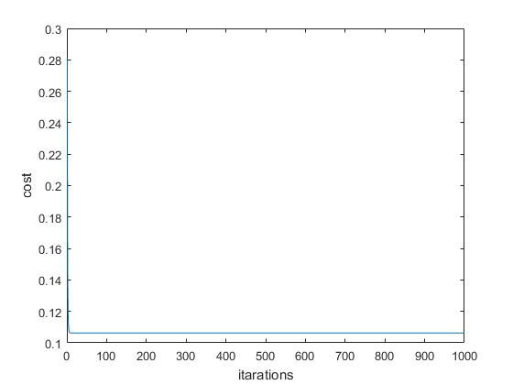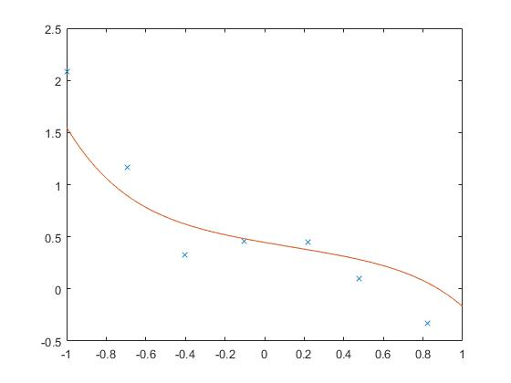

Alpha=0.1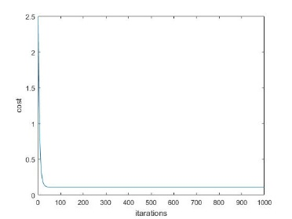

Alpha=0.6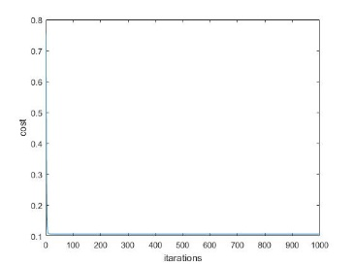

Alpha=10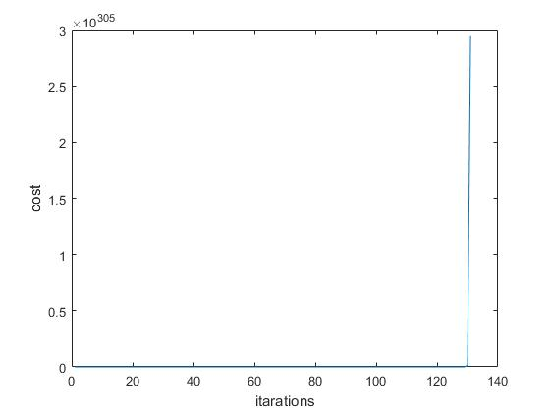

The learning rate is the best at 0.6, since cost lowest.

Lamda= 0.1, 1, 10, 15, 20, 100

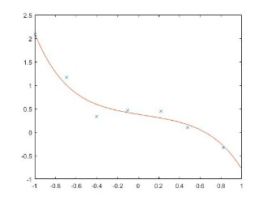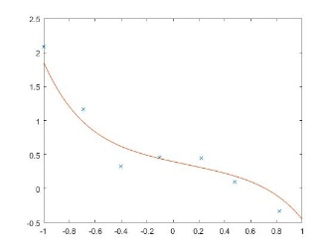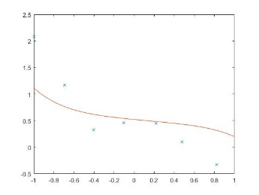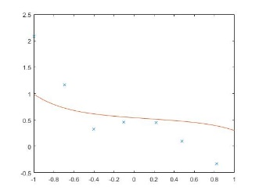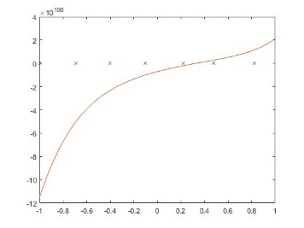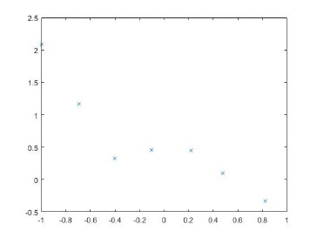

We know that if Lambda gets higher, the shape of hypothesis becomes a straight-like-line, which also causing the case of under-fit.

**Part B**

Task 1function output=sigmoid(x)

%output = 0;

% modify this to return z passed through the sigmoid function

%%%%%%%%%%%%%%%%%%%%%%%%

%output= zeros(size(x));

%output=sigmoid(x)

output= 1.0 ./ ( 1.0 + exp(-x));

end

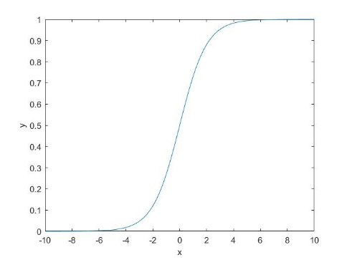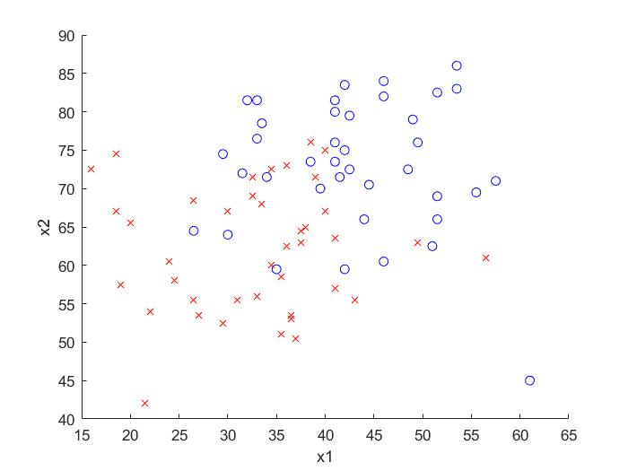

**Task 2**

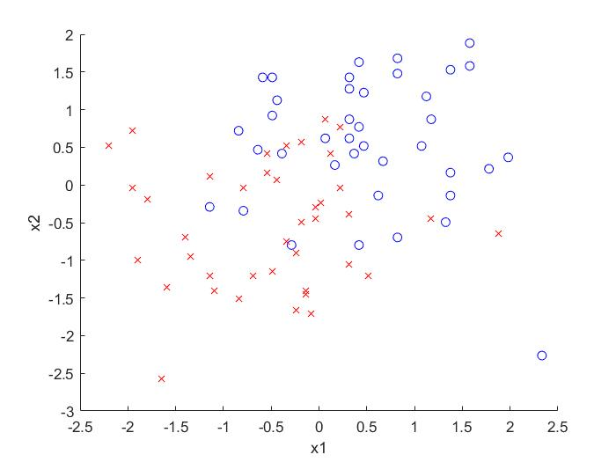

Uncomment [X,mean,std] = normalise_features(X);

The scale is smaller than un-normalized.

**Task3**

hypothesis = (X(i,:)*theta');

%%%%%%%%%%%%%%%%%%%%%%%%

result=sigmoid(hypothesis);

**Task4**

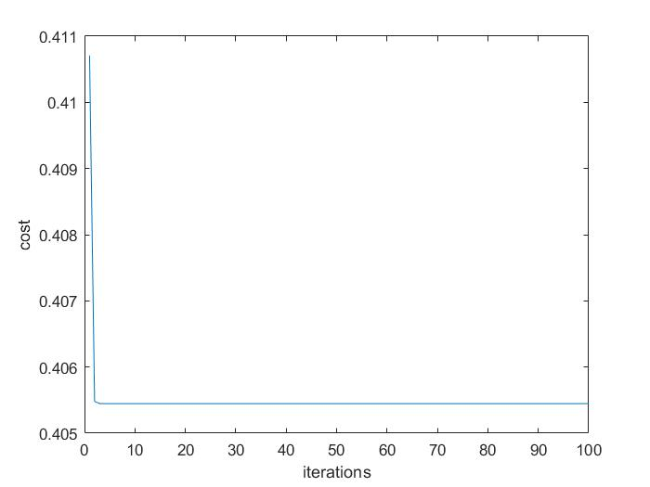

The final error is 0.40545.

**Task 5**

% modify this:

y1 = -(theta(2)*min_x1-1 )/theta(3);

% modify this:

y2 = -(theta(2)*max_x1-1 )/theta(3);

Uncomment plot_data_function(X,y)

plot_boundary(X,t);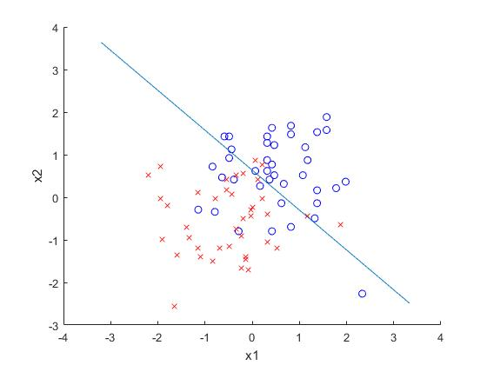

**Task 6**

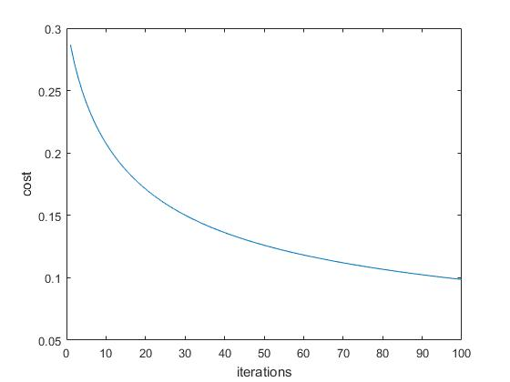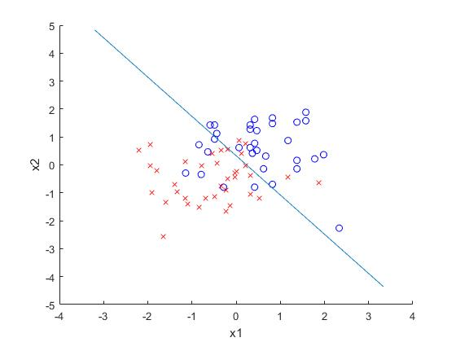

Training error: 0.033891 Test error: 0.76183

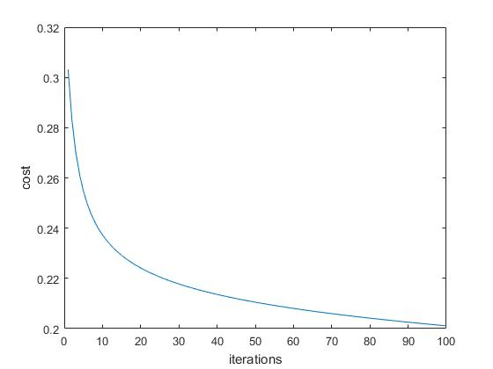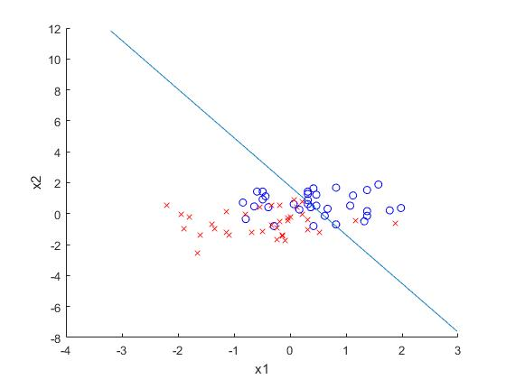

Training error: 0.20109 Test error: 0.49358

When the training data and testing data points get close the better line and lower cost we have. Training error and test error are close to each other. As a result, the bottom graphs and better than the top graphs.

**Task7**

for i=1:size(X:1)

X(i,4)=X(i,2)*X(i,3);

end

%here append x_2 * x_2 (remember that x_1 is the bias

for i=1:size(X:1)

X(i,5)=X(i,2)*X(i,2);

end

%here append x_3 * x_3 (remember that x_1 is the bias

for i=1:size(X:1)

X(i,6)=X(i,3)*X(i,3);

end

The Final error is 0.38567 lower and close the previous one. This is because we have normalized the data. We are just scaling the parameters that we have.

**Task8**

for i=1:size(X:1)

X(i,4)=X(i,2)*X(i,3);

end

%here append x_2 * x_2 (remember that x_1 is the bias

for i=1:size(X:1)

X(i,5)=X(i,2)*X(i,2);

end

%here append x_3 * x_3 (remember that x_1 is the bias

for i=1:size(X:1)

% update cost_array

cost_array(it)=compute_cost(X, y, theta);

% add code here: to update cost_array_training and cost_array_test

cost_array_training(it)=compute_cost(X, y, theta);

cost_array_test(it)=compute_cost(test_X,test_y, theta);

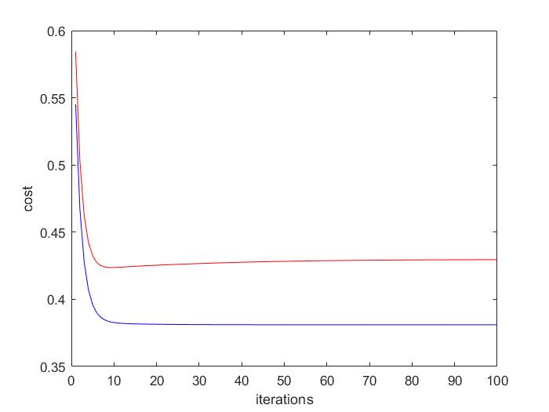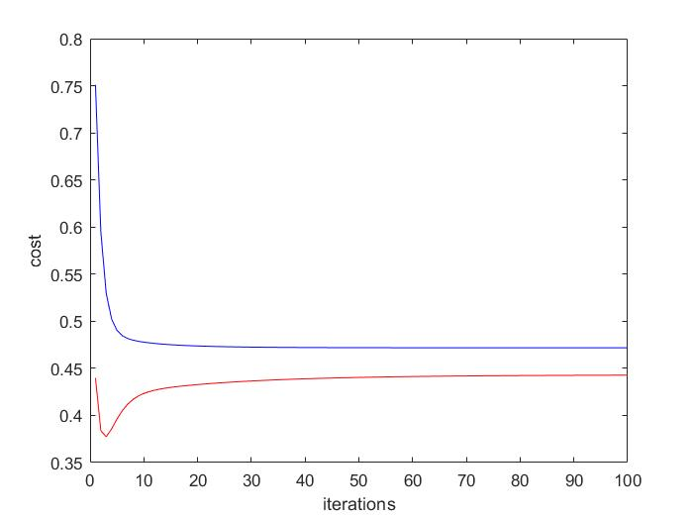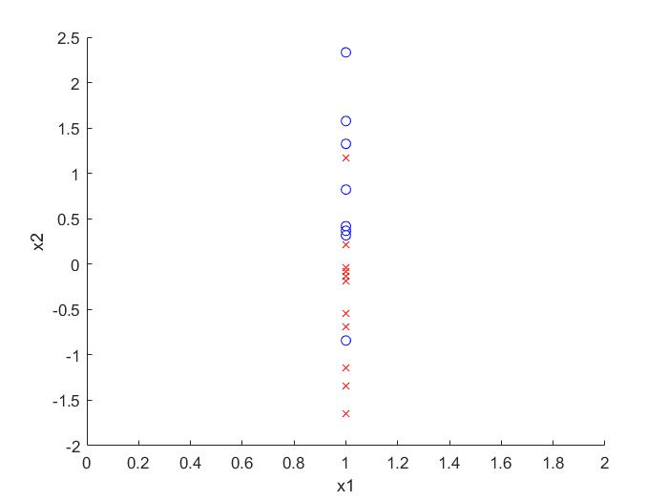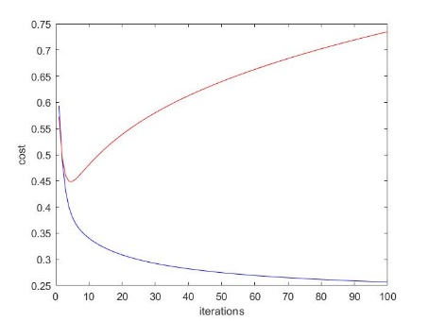

**Training:0.32742**

**Test:0.4793**

**Task9**

**Task10**

function sigmoid_output=sigmoid(z)

% change this to apply the sigmoid to the data below:

sigmoid_output=1.0./(1.0+exp(-z));

%sigmoid_output = 0.0;

end

% Step 2. Hidden deltas (used to change weights from input --> output).

hidden_deltas = zeros(1,length(nn.hidden_neurons));

% hint... create a for loop here to iterate over the hidden neurons and for each

% hidden neuron create another for loop to iterate over the ouput neurons

for j = 1:length(nn.hidden_neurons)

for i = 1:length(outputs)

sum_over_outputs(j,i)=nn.hidden_weights(j,i)*output_deltas(i);

end

hidden_deltas(j)=sigmoid_derivative(nn.hidden_neurons(j)*sum_over_outputs(j,i));

end

% Step 3. update weights output --> hidden

for i=1:length(nn.hidden_neurons)

for j=1:length(output_deltas)

nn.output_weights(i,j) =nn.output_weights(i,j) -(output_deltas(j) * nn.hidden_neurons(i) * learning_rate);

end

end

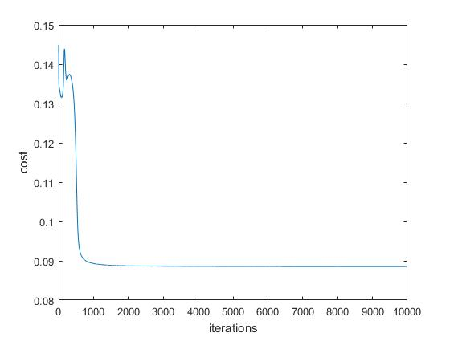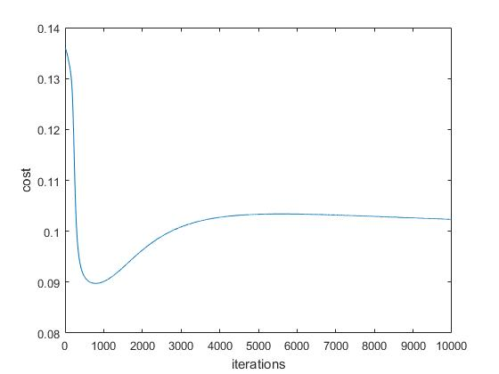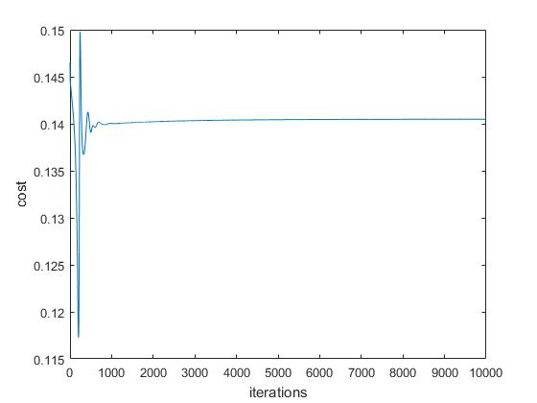

Learning_rate=1000, 100, 0.01

When learning rate=1000, the actual output tend to be closer to each other, 0.13327, 0.65614, 0.65834, 0.65718 and the cost is converged faster than the others which is 0.088539.

**Task11**

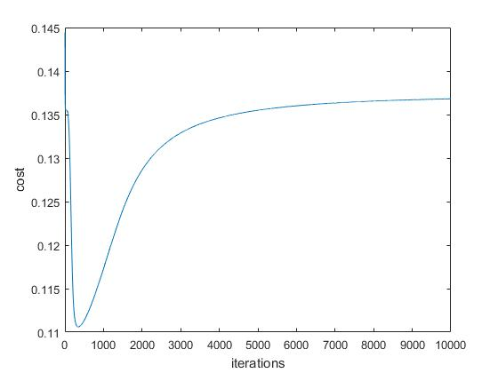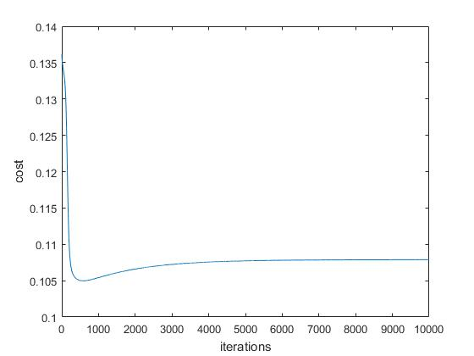

Using AND, the function is seemed to be converged faster than XOR, since we can use either conditions.

**Task12**

For logistic regression, we will identify 3 species of Iris by their mean, std, min, %, 50%,75% and max of sepal length, sepal width, petal length, and petal width. Then we will group their group to make a pivot table of their mean. We limit the distance between the mean and different points. Finally we draw a decision boundary of each kind. Meanwhile, Neural network runs a kind 4 times each to group them up, either yes or no happens on each node. Neural network can also solve XOR too.

**Task12**

iris.m not-found!!!!

There is no way I am able to do it.

Do not deduce my marks please.